**Chapter 4**

**HARDWARE IMPLEMENTATION**

Here we are using ARM LPC2148 Microcontroller as the central hub in the network. 8051 is being used in vehicles as the control unit for communication between vehicles. We use ZigBee to transmit and receive data.

To avoid traffic congestion we are using IR sensors for detecting the speed of the vehicle and hence determine which vehicle can cross the junction.

For accident detection we connect the vibration sensor with ARM microcontroller. ARM microcontroller is interfaced with ESP8266 Wi-Fi module. The data on the hub is uploaded and accessed online.

**4.1 POWER SUPPLY UNIT**

The circuit needs two different voltages, +5V & +12V, to work. These dual voltages are supplied by this specially designed power supply.

The power supply, unsung hero of every electronic circuit, plays very important role in smooth running of the connected circuit. The voltage +5V is required to drive the IC and +12V is required to generate potential difference in relay so that it can act as an electronic switch.

The main object of this ‘power supply’ is, as the name itself implies, to deliver the required amount of stabilized and pure power to the circuit. Every typical power supply contains the following sections:

**1. Step-down Transformer -** The conventional supply, which is generally available to the user, is 230V AC. It is necessary to step down the mains supply to the desired level. This is achieved by using suitably rated step-down transformer. While designing the power supply, it is necessary to go for little higher rating transformer than the required one. The reason for this is, for proper working of the regulator IC (say KIA 7805) it needs at least 2.5V more than the expected output voltage.

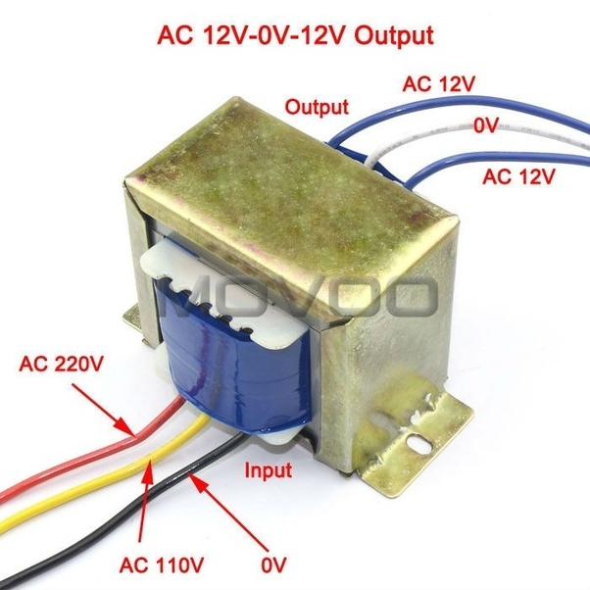

Fig 4.1 Step Down Transformer

**2. Rectifier stage -** Then the step-downed Alternating Current is converted into Direct Current. This rectification is achieved by using passive components such as diodes. If the power supply is designed for low voltage/current drawing loads/circuits (say +5V), it is sufficient to employ full-wave rectifier with centre-tap transformer as a power source. While choosing the diodes the PIV rating is taken into consideration.

**3. Filter stage -** But this rectified output contains some percentage of superimposed AC ripples. So to filter these AC components filter stage is built around the rectifier stage. The cheap, reliable, simple and effective filtering for low current drawing loads (say upto 50 mA) is done by using shunt capacitors. This electrolytic capacitor has polarities, take care while connecting the circuit.

**4. Voltage Regulation -** The filtered DC output is not stable. It varies in accordance with the fluctuations in mains supply or varying load current. This variation of load current is observed due to voltage drop in transformer windings, rectifier and filter circuit. These variations in DC output voltage may cause inaccurate or erratic operation or even malfunctioning of many electronic circuits. For example, the circuit boards which are implanted by CMOS or TTL ICs.

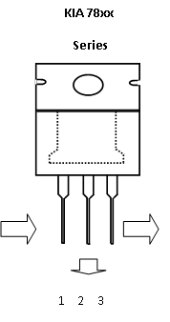

Fig 4.2 Voltage Regulator 78XX Series

The stabilization of D.C. output is achieved by using the IC of three terminal voltage regulator. This regulator IC comes in two flavors: 78XX for positive voltage output and 79XX for negative voltage output. For example 7805 gives +5V output and 7905 gives -5V stabilized output. These regulator ICs have in-built short-circuit protection and auto-thermal cutout provisions. If the load current is very high the IC needs ‘heat sink’ to dissipate the internally generated power.

**4.1.1 CIRCUIT DESCRIPTION**

A DC power supply which maintains the output voltage constant irrespective of ac mains fluctuations or load variations is known as regulated DC power supply. It is also referred as full-wave regulated power supply as it uses four diodes in bridge fashion with the transformer. This laboratory power supply offers excellent line and load regulation and output voltages of +5V & +12 V at output currents up to 1 amp.

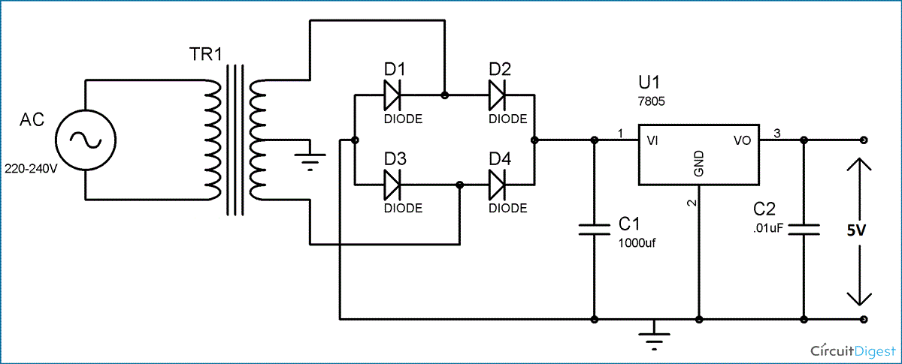

Fig 4.3 Circuit Diagram of Power Supply Unit

**4.1.2 COMPONENTS LIST**

**SEMICONDUCTORS**

|  |  |  |
| --- | --- | --- |
| COMPONENT | SPECIFICATION | QUANTITY |
| U1 | LM7805 Regulator IC | 1 |
| D1 to D4 | 1N4007 Rectifier Diodes | 4 |

**CAPACITORS**

|  |  |  |
| --- | --- | --- |
| COMPONENT | SPECIFICATION | QUANTITY |
| C1 | 1000 µf/25V Electrolytic | 1 |
| C2 | 0.01µF Ceramic Disc type | 1 |

**MISCELLANEOUS**

|  |  |  |
| --- | --- | --- |
| COMPONENT | SPECIFICATION | QUANTITY |
| TR1 | 230V AC Pri,13-0-13 1Amp Sec Transformer | 1 |

Table 4.1 Power Supply Unit Components

**4.2 LM7805 REGULATOR IC**

All voltage sources cannot able to give fixed output due to fluctuations in the circuit. For getting constant and steady output, the voltage regulators are implemented. The integrated circuits which are used for the regulation of voltage are termed as voltage regulator ICs. Here, we can discuss about IC 7805.

The voltage regulator IC 7805 is actually a member of 78xx series of voltage regulator ICs. It is a fixed linear voltage regulator. The xx present in 78xx represents the value of the fixed output voltage that the particular IC provides. For 7805 IC, it is +5V DC regulated power supply. This regulator IC also adds a provision for a heat sink. The input voltage to this voltage regulator can be up to 35V, and this IC can give a constant 5V for any value of input less than or equal to 35V which is the threshold limit.

The AC power supply gets converted into constant DC by this circuit. By the help of a voltage regulator DC, unregulated output will be fixed to a constant voltage. The circuit is made up of linear voltage regulator 7805 along with capacitors and resistors with bridge rectifier made up from diodes. From giving an unchanging voltage supply to building confident that output reaches uninterrupted to the appliance, the diodes along with capacitors handle elevated efficient signal conveyed.

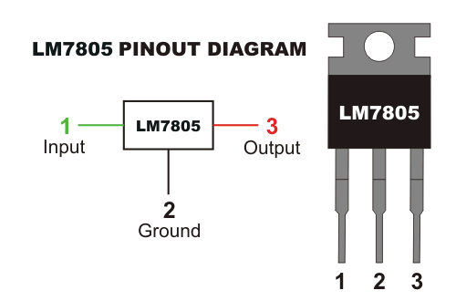

Fig 4.4 LM7805 IC

|  |  |  |
| --- | --- | --- |
| **PIN NO.** | **PIN** | **DESCRIPTION** |
| 1 | INPUT | In this pin of the IC positive unregulated voltage is given in regulation. |
| 2 | GROUND | In this pin where the ground is given. This pin is neutral for equally the input and output. |
| 3 | OUTPUT | The output of the regulated 5V volt is taken out at this pin of the IC regulator. |

Table 4.2 Pin Configurations of LM7805

**4.2.2 DESCRIPTION**

As we have previously talked about that regulated power supply is a device that mechanized on DC voltages and also it can uphold its output accurately at a fixed voltage all the time  although if there is a significant alteration in the DC input voltage.

ICs regulator is mainly used in the circuit to maintain the exact voltage which is followed by the power supply. For the checking of gigantic alterations in the input as well as in the output filter, capacitors are used. While the bypass capacitors are used to check the small period spikes on the input and output level. Bypass capacitors are mainly of small values that are used to bypass the small period pulses straightly into the Earth.

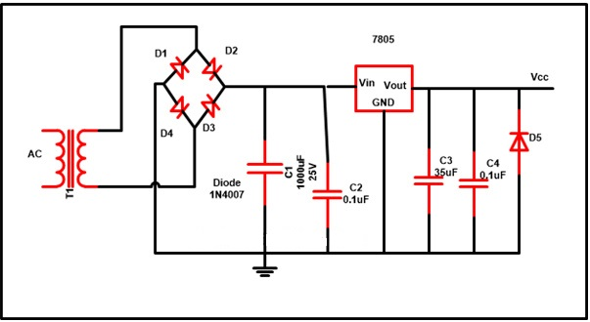

Fig 4.5 Regulated Power Supply

|  |  |
| --- | --- |
| **COMPONENT** | **FUNCTION** |
| C1 | This capacitor is known as bypass capacitor and is employed to bypass extremely tiny duration spikes to the ground with no distress the other components. |
| C2 | C2 is the filter capacitor employed to steady the slow changes in the voltage applied at the input of the circuit. Escalating the value of the capacitor amplify the stabilization as well as the declining value of the capacitor reduces the stabilization. Moreover this capacitor is not alone capable to ensure very constricted period spikes emerge at the input. |
| C3 | C3 is known as a filter capacitor employed in the circuit to steady the slow alterations in the output voltage. Raising the value of the capacitor enlarges the stabilization furthermore declining the value of the capacitor declined the stabilization. Moreover this capacitor is not alone capable to ensure very fine duration spikes happen at the output. |
| C4 | C4 is known as bypass capacitor and worked to bypass very small period spikes to the earth with no influence the other components. |
| U1 | U1 is the IC with positive DC and it upholds the output voltage steady exactly at a constant value even although there are major deviation in the input voltage. |

Table 4.3 Regulated Power Supply Components Functions

The output generated from the unregulated DC output is susceptible to the fluctuations of the input signal.IC voltage regulator  is connected with bridge rectifier in series in these project so to steady the DC output against the variations in the input DC voltage.To obtain a stable output of 5V, IC 7805 is attached with 6-0-6V along with 500mA step down transformer as well as with rectifier.To suppress the oscillation which might generate in the regulator IC, C2 capacitor of 0.1 uF value is used.

When the power supply filter is far away from the regulated IC capacitor C2 is used .Ripple rejection in the regulator is been improved by C4 capacitor (35uf) by avoiding the ripple voltage to be amplified at the regulator output. The output voltage is strengthen and deduction of the output voltage is done capacitor C3 (0.1uF). To avoid the chance of the input get shorted D5 diode is used to save the regulator. If D5 is not presented in the circuit, the output capacitor can leave its charge immediately during low impedance course inside the regulators.

**4.2.3 COMPONENTS LIST**

**SEMICONDUCTORS**

|  |  |  |
| --- | --- | --- |
| **COMPONENT** | **SPECIFICATION** | **QUANTITY** |
| U1 | LM7805 Regulator IC | 1 |
| D1 to D4 | 1N4007 Rectifier Diodes | 4 |

**CAPACITORS**

|  |  |  |
| --- | --- | --- |
| **COMPONENT** | **SPECIFICATION** | **QUANTITY** |
| C1 | 1000 µf/25V Electrolytic | 1 |
| C2 & C4 | 0.01µF Ceramic Disc type | 2 |
| C3 | 35 µf/25V Electrolytic | 1 |

**MISCELLANEOUS**

|  |  |  |
| --- | --- | --- |
| **COMPONENT** | **SPECIFICATION** | **QUANTITY** |
| T1 | 230V AC Pri,13-0-13 1Amp Sec Transformer | 1 |

Table 4.4 RPS Components List

**4.3 ARM LPC2148**

The LPC2141/42/44/46/48 microcontrollers are based on a 16-bit/32-bit ARM7TDMI-S CPU with real-time emulation and embedded trace support, that combine microcontroller with embedded high speed flash memory ranging from 32 kB to 512 kB. A 128-bit wide memory interface and a unique accelerator architecture enable 32-bit code execution at the maximum clock rate. For critical code size applications, the alternative 16-bit Thumb mode reduces code by more than 30 % with minimal performance penalty.

Due to their tiny size and low power consumption, LPC2141/42/44/46/48 are ideal for applications where miniaturization is a key requirement, such as access control and point-of-sale. Serial communications interfaces ranging from a USB 2.0 Full-speed device, multiple UARTs, SPI, SSP to I2C-bus and on-chip SRAM of 8 kB up to 40 kB, make these devices very well suited for communication gateways and protocol converters, soft modems, voice recognition and low end imaging, providing both large buffer size and high processing power. Various 32-bit timers, single or dual 10-bit. ADC(s), 10-bit DAC, PWM channels and 45 fast GPIO lines with up to nine edge or level sensitive external interrupt pins make these microcontrollers suitable for industrial control and medical systems.

This generation introduced the Thumb 16-bit instruction set providing improved code density compared to previous designs. The most widely used ARM7 designs implement the ARMv4T architecture, but some implement ARMv3 or ARMv5TEJ. ARM7TDMI has 37 registers (31 GPR and 6 SPR). All these designs use a [Von Neumann architecture](https://en.wikipedia.org/wiki/Von_Neumann_architecture) ,thus the few versions containing a cache do not separate data and instruction caches.

It is a versatile processor designed for mobile devices and other low power electronics. This processor architecture is capable of up to 130 [MIPS](https://en.wikipedia.org/wiki/Million_Instructions_Per_Second) on a typical [0.13 µm process](https://en.wikipedia.org/wiki/130_nanometer). The ARM7TDMI processor core implements [ARM architecture](https://en.wikipedia.org/wiki/ARM_architecture) v4T. The processor supports both 32-bit and 16-bit instructions via the ARM and Thumb instruction sets.

**4.3.1 PIN DIAGRAM**

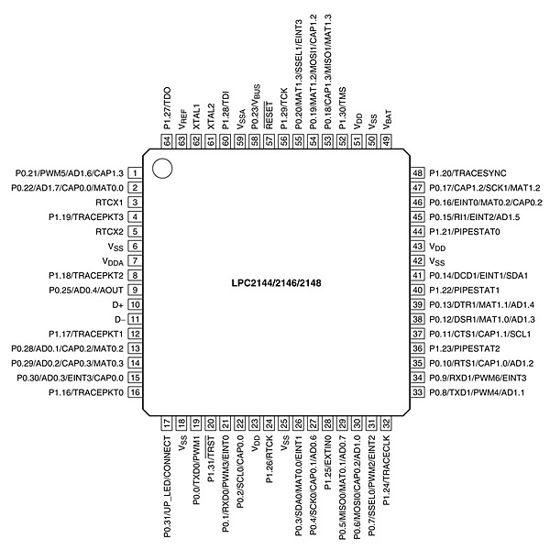

Fig 4.6 Pin Diagram ARM7

**4.3.1 FEATURES**

1. 16-bit/32-bit ARM7TDMI-S microcontroller in a tiny LQFP64 package.
2. 8 kB to 40 kB of on-chip static RAM and 32 kB to 512 kB of on-chip flash memory. 128-bit wide interface/accelerator enables high-speed 60 MHz operation.

1. In-System Programming/In-Application Programming (ISP/IAP) via on-chip boot loader software. Single flash sector or full chip erase in 400 ms and programming of 256 bytes in 1 ms.
2. Embedded ICE RT and Embedded Trace interfaces offer real-time debugging with the on-chip Real Monitor software and high-speed tracing of instruction execution.
3. USB 2.0 Full-speed compliant device controller with 2 kB of endpoint RAM. In addition, the LPC2146/48 provides 8 kB of on-chip RAM accessible to USB by DMA.
4. One or two (LPC2141/42 vs. LPC2144/46/48) 10-bit ADCs provide a total of

6/14 analog inputs, with conversion times as low as 2.44 μs per channel.

1. Single 10-bit DAC provides variable analog output (LPC2142/44/46/48 only).
2. Two 32-bit timers/external event counters (with four capture and four compare

Channels each), PWM unit (six outputs) and watchdog.

1. Low power Real-Time Clock (RTC) with independent power and 32 kHz clock input.

1. Multiple serial interfaces including two UARTs (16C550), two Fast I2C-bus (400 kbit/s), SPI and SSP with buffering and variable data length capabilities.
2. Vectored Interrupt Controller (VIC) with configurable priorities and vector addresses.
3. Up to 45 of 5 V tolerant fast general purpose I/O pins in a tiny LQFP64 package,.
4. Up to 21 external interrupt pins available.
5. 60 MHz maximum CPU clock available from programmable on-chip PLL with Settling time of 100 μs.
6. On-chip integrated oscillator operates with an external crystal from 1 MHz to 25 MHz.

1. Power saving modes include Idle and Power-down.
2. Individual enable/disable of peripheral functions as well as peripheral clock scaling for additional power optimization.
3. Processor wake-up from Power-down mode via external interrupt or BOD.
4. Single power supply chip with POR and BOD circuits:
5. CPU operating voltage range of 3.0 V to 3.6 V (3.3 V ± 10 %) with 5 V tolerant I/O pads.

**4.3.3 MEMORY**

LPC2148 has 32kB on chip SRAM and 512kB on chip FLASH memory. This chip has built in support up to 2kB end point USB RAM. This memory is more than enough for almost all applications. Let’s understand the function of this huge memory space in LPC2148.

FLASH Memory System: The LPC2148 has 512kB flash memory. This memory may used for both code and data storage. The flash memory can be programmed by various ways

1. Using serial built in JTAG Interface
2. Using In-System Programming (ISP)
3. By means of In-Application Programming (IAP) capabilities

The application program, using IAP functions may also erase and/or program the FLASH while the application is running.  When the LPC2148 on chip bootloader is used, 500kB of flash memory is available for user code.

**RAM Memory System -** LPC2148 provides 32kB of static RAM which may be used for code and/or data storage. It may be accessed as 8-bit, 16-bit and 32-bits.

**4.3.4 INPUT/OUTPUT PORTS (GPIO of LPC2148)**

Understanding what is IO Ports and how to use them is very important. It’s because when we see micro chip, we’ll find a black box i.e. IC with some pins. LPC2148 has two IO ports each of 32-bit wide, provided by 64 IO pins. Ports are named as P0 and P1. Pins of each port labeled as Px.y where “x” stands for port number, 0 or 1. Where “y” stands for pin number usually between 0 to 31. Each pin can perform multiple functions. For example: Pin no.1 which is P0.21 serves as GPIO as well as PWM5, AD1.6 (A/D converter1, input 6), CAP1.3 (Capture input for Timer1, Channel 3).

Ports P0.0 – P0.31 and Ports P1.16-P1.31 are Input/Output pins. They are General purpose input/output. The number of GPIOs actually available depends on the use of alternate functions.

PORT0 is a 32-bit I/O port with individual direction controls for each bit. Total of 28 pins of the Port 0 can be used as a general purpose bi-directional digital I/Os while P0.31 provides digital output functions only. The operation of port 0 pins depends upon the pin function selected via the pin connect block. Pins P0.24, P0.26 and P0.27 are not available.

PORT 1 is a 32-bit bi-directional I/O port with individual direction controls for each bit. The operation of port 1 pins depends upon the pin function selected via the pin connect block. Pins 0 through 15 of port 1 are not available.

PORT0 and PORT1 are controlled via two groups of registers explained below.

**IOPIN**

This is GPIO Port Pin value register. The Current State of the GPIO configured port pins can always be read from this register, regardless of pin direction.

**IODIR**

This is GPIO Port Direction control register. This register individually Controls the direction of each Port Pin.

**IOCLR**

This is GPIO Port Output Clear registers. This register controls the state of output pins. Writing ones produces lows at the corresponding port pins and clears the corresponding bits in the IOSET register. Writing zeroes has no effect.

**IOSET**

This is GPIO Port Output Set registers. This register controls the state of output pins in conjunction with the IOCLR register. Writing ones produces highs at the corresponding port pins. Writing zeroes has no effect.

**4.3.5 UART**

The LPC2141/42/44/46/48 each contain two UARTs. In addition to standard transmit and receive data lines, the LPC2144/46/48 UART1 also provides a full modem control handshake interface.Compared to previous LPC2000 microcontrollers, UARTs in PC2141/42/44/46/48introduce a fractional baud rate generator for both UARTs, enabling these microcontrollers to achieve standard baudrates such as 115200 with any crystal frequency above 2 MHz. In addition, auto-CTS/RTS flow-control functions are fully implemented in hardware (UART1 in LPC2144/46/48 only).

**4.3.6 FEATURES**

**•** 16 byte Receive and Transmit FIFOs.

**•** Register locations conform to ‘550 industry standard.

**•** Receiver FIFO trigger points at 1, 4, 8, and 14 bytes

**•** Built-in fractional baud rate generator covering wide range of baud rates without a need for external crystals of particular values.

**•** Transmission FIFO control enables implementation of software (XON/XOFF) flow control on both UARTs.

**•** LPC2144/46/48 UART1 equipped with standard modem interface signals. This module also provides full support for hardware flow control (auto-CTS/RTS).

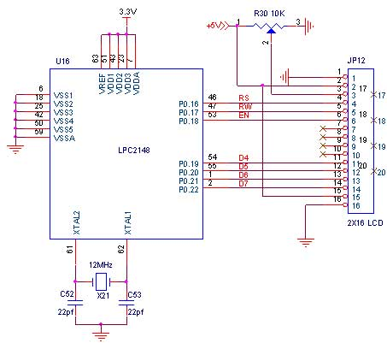

Fig 4.7 Interfacing Diagram of LCD With ARM7

**4.4 8051 Microcontroller**

The 8051 Microcontroller was designed in 1980’s by Intel. Its foundation was on Harvard Architecture and was developed principally for bringing into play in Embedded Systems. At first it was created by means of NMOS technology but as NMOS technology needs more power to function therefore Intel re-intended Microcontroller 8051 employing CMOS technology and a new edition came into existence with a letter ‘C’ in the title name, for illustration: 80C51. These most modern Microcontrollers need fewer amount of power to function in comparison to their forerunners.

There are two buses in 8051 Microcontroller one for program and other for data. As a result, it has two storage rooms for both program and data of 64K by 8 size. The microcontroller comprises of 8 bit accumulator & 8 bit processing unit. It also consists of 8-bit B register as majorly functioning blocks and 8051 microcontroller programming is done with embedded C language using Keil software. It also has a number of other 8 bit and 16-bit registers.

For internal functioning & processing Microcontroller 8051 comes with integrated built-in RAM. This is prime memory and is employed for storing temporary data. It is unpredictable memory i.e. its data can get be lost when the power supply to the Microcontroller switched OFF.

**4.4.1 8051 MICROCONTROLLER ARCHITECTURE:**

Microcontroller 8051 block diagram is shown below. Let’s have a closer look on features of 8051 microcontroller design:

[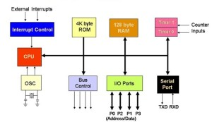](https://www.elprocus.com/wp-content/uploads/2013/02/Block-Diagram-of-8051-Microcontroller.jpg)

Fig 4.8 Block Diagram of 8051 Microcontroller

**CPU (Central Processor Unit)**

As you may be familiar that Central Processor Unit or CPU is the mind of any processing machine. It scrutinizes and manages all processes that are carried out in the Microcontroller. User has no power over the functioning of CPU. It interprets program printed in storage space (ROM) and carries out all of them and do the projected duty. CPU manages different types of registers in 8051 microcontroller.

**Interrupts**

As the heading put forward, Interrupt is a sub-routine call that reads the Microcontroller’s key function or job and helps it to perform some other program which is extra important at that point of time. The characteristic of 8051 Interrupt is extremely constructive as it aids in emergency cases. Interrupts provides us a method to postpone or delay the current process, carry out a sub-routine task and then all over again restart standard program implementation.

The Micro-controller 8051 can be assembled in such a manner that it momentarily stops or break the core program at the happening of interrupt. When sub-routine task is finished then the implementation of core program initiates automatically as usual. There are 5 interrupt supplies in 8051 Microcontroller, two out of five are peripheral interrupts, two are timer interrupts and one is serial port interrupt.

**Memory**

Micro-controller needs a program which is a set of commands. This program enlightens Microcontroller to perform precise tasks. These programs need a storage space on which they can be accumulated and interpret by Microcontroller to act upon any specific process. The memory which is brought into play to accumulate the program of Microcontroller is recognized as Program memory or code memory. In common language it’s also known as Read Only Memory or ROM.

Microcontroller also needs a memory to amass data or operands for the short term. The storage space which is employed to momentarily data storage for functioning is acknowledged as Data Memory and we employ Random Access Memory or RAM for this principle reason. Microcontroller 8051 contains code memory or program memory 4K so that is has 4KB Rom and it also comprise of data memory (RAM) of 128 bytes.

**Bus**

Fundamentally Bus is a group of wires which functions as a communication canal or mean for the transfer Data. These buses comprise of 8, 16 or more cables. As a result, a bus can bear 8 bits, 16 bits all together. There are two types of buses:

1. **Address Bus:** Microcontroller 8051 consists of 16-bit address bus. It is brought into play to address memory positions. It is also utilized to transmit the address from Central Processing Unit to Memory.
2. **Data Bus:** Microcontroller 8051 comprise of 8 bits data bus. It is employed to cart data.

**Oscillator**

As we all make out that Microcontroller is a digital circuit piece of equipment, thus it needs timer for its function. For this function, Microcontroller 8051 consists of an on-chip oscillator which toils as a time source for CPU (Central Processing Unit). As the productivity thumps of oscillator are steady as a result, it facilitates harmonized employment of all pieces of 8051 Microcontroller. Input/output Port: As we are acquainted with that Microcontroller is employed in embedded systems to manage the functions of devices.

Thus, to gather it to other machinery, gadgets or peripherals we need I/O (input/output) interfacing ports in Micro-controller. For this function Micro-controller 8051 consists of 4 input/output ports to unite it to other peripherals.

**Timers/Counters**

Micro-controller 8051 is incorporated with two 16 bit counters & timers. The counters are separated into 8-bit registers. The timers are utilized for measuring the intervals, to find out pulse width etc.

**4.4.2 8051 MICROCONTROLLER PIN DIAGRAM**

[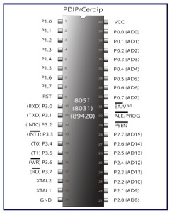](https://www.elprocus.com/wp-content/uploads/2013/02/8051-Microcontroller-Pin-Diagram.jpg)

Fig 4.9 8051 Microcontroller Pin Diagram

For explaining the pin diagram and pin configuration of microcontroller 8051, we are taking into deliberation a 40 pin Dual inline package (DIP). Now let’s study through pin configuration in brief:

**Pins 1 – 8:** recognized as Port 1. Different from other ports, this port doesn’t provide any other purpose. Port 1 is a domestically pulled up, quasi bi-directional Input/output port.

**Pin 9:** As made clear previously RESET pin is utilized to set the micro-controller 8051 to its primary values, whereas the micro-controller is functioning or at the early beginning of application. The RESET pin has to be set elevated for two machine rotations.

**Pins 10 – 17:** recognized as Port 3. This port also supplies a number of other functions such as timer input, interrupts, serial communication indicators TxD & RxD, control indicators for outside memory interfacing WR & RD, etc. This is a domestic pull up port with quasi bi-directional port within.

**Pins 18 and 19:** These are employed for interfacing an outer crystal to give system clock.

**Pin 20:** Titled as Vss – it symbolizes ground (0 V) association.

**Pins- 21-28:** recognized as Port 2 (P 2.0 – P 2.7) – other than serving as Input/output port, senior order address bus indicators are multiplexed with this quasi bi-directional port.

**Pin- 29:** Program Store Enable or PSEN is employed to interpret sign from outer program memory.

**Pin-30:** External Access or EA input is employed to permit or prohibit outer memory interfacing. If there is no outer memory need, this pin is dragged high by linking it to Vcc.

**Pin-31:** Aka Address Latch Enable or ALE is brought into play to de-multiplex the address data indication of port 0 (for outer memory interfacing). Two ALE throbs are obtainable for every machine rotation.

**Pins 32-39:** recognized as Port 0 (P0.0 to P0.7) – other than serving as Input/output port, low order data & address bus signals are multiplexed with this port (to provide the use of outer memory interfacing). This pin is a bi directional Input/output port (the single one in microcontroller 8051) and outer pull up resistors are necessary to utilize this port as Input/output.

**Pin-40:** termed as Vcc is the chief power supply. By and large it is +5V DC.

**4.4.3 APPLICATIONS OF 8051 MICROCONTROLLER**

The microcontroller 8051 applications include large amount of machines, principally because it is simple to incorporate in a project or to assemble a machine around it. The following are the key spots of spotlight:

1. **Energy Management:** Competent measuring device systems aid in calculating energy consumption in domestic and industrialized applications. These meter systems are prepared competent by integrating microcontrollers.
2. **Touch screens:** A high degree of microcontroller suppliers integrate touch sensing abilities in their designs. Transportable devices such as media players, gaming devices & cell phones are some illustrations of micro-controller integrated with touch sensing screens.
3. **Automobiles:** The microcontroller 8051 discovers broad recognition in supplying automobile solutions. They are extensively utilized in hybrid motor vehicles to control engine variations. In addition, works such as cruise power and anti-brake mechanism has created it more capable with the amalgamation of micro-controllers.
4. **Medical Devices:** Handy medicinal gadgets such as glucose & blood pressure monitors bring into play micro-controllers, to put on view the measurements, as a result, offering higher dependability in giving correct medical results.
5. **Medical Devices:** Handy medicinal gadgets such as glucose & blood pressure monitors bring into play micro-controllers, to put on view the measurements, as a result, offering higher dependability in giving correct medical results.

**4.5 ZIGBEE WIRELESS TECHNOLOGY**

In this present communication world there are numerous high data rate communication standards that are available, but none of these meet the sensors’ and control devices’ communication standards. These high-data rate communication standards require low-latency and low-energy consumption even at lower bandwidths. The available proprietary wireless systems’ ZigBee technology is low-cost and low-power consumption and its excellent and superb characteristics makes this communication best suited for several embedded applications industrial control, and home automation, and so on.

**4.5.1 WHAT IS ZIGBEE TECHNOLOGY?**

[](https://www.elprocus.com/wp-content/uploads/2014/05/26.jpg)

Fig 4.10 ZigBee Technology

ZigBee communication is specially built for control and sensor networks on IEEE 802.15.4 standard for wireless personal area networks (WPANs), and it is the product from ZigBee alliance. This communication standard defines physical and Media Access Control (MAC) layers to handle many devices at low-data rates. These ZigBee’s WPANs operate at 868 MHz, 902-928MHz and 2.4 GHz frequencies. The date rate of 250 kbps is best suited for periodic as well as intermediate two-way transmission of data between sensors and controllers.

[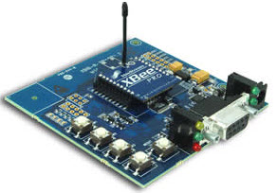](https://www.elprocus.com/wp-content/uploads/2014/05/18.jpg)

Fig 4.11 ZigBee Modem

ZigBee is low-cost and low-powered mesh network widely deployed for controlling and monitoring applications where it covers 10-100 meters within the range. This communication system is less expensive and simpler than the other proprietary short-range wireless sensor networks as Bluetooth and Wi-Fi.

ZigBee supports different network configurations for master to master or master to slave communications. And also, it can be operated in different modes as a result the battery power is conserved. ZigBee networks are extendable with the use of routers and allow many nodes to interconnect with each other for building a wider area network.

**4.5.2 ZIGBEE ARCHITECTURE**

[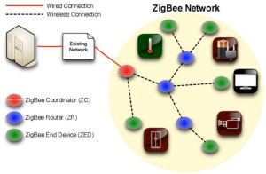](https://www.elprocus.com/wp-content/uploads/2014/05/43.jpg)

Fig 4.12 ZigBee System Structure

ZigBee system structure consists of three different types of devices such as ZigBee coordinator, Router and End device. Every ZigBee network must consist of at least one coordinator which acts as a root and bridge of the network. The coordinator is responsible for handling and storing the information while performing receiving and transmitting data operations. ZigBee routers act as intermediary devices that permit data to pass to and fro through them to other devices. End devices have limited functionality to communicate with the parent nodes such that the battery power is saved as shown in the figure. The number of routers, coordinators and end devices depends on the type of network such as star, tree and mesh networks.

ZigBee protocol architecture consists of a stack of various layers where IEEE 802.15.4 is defined by physical and MAC layers while this protocol is completed by accumulating ZigBee’s own network and application layers.

[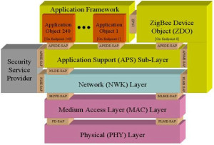](https://www.elprocus.com/wp-content/uploads/2014/05/34.jpg)

Fig 4.13 ZigBee Protocol Architecture

**Physical Layer**: This layer does modulation and demodulation operations up on transmitting and receiving signals respectively. This layer’s frequency, date rate and number of channels are given below.

[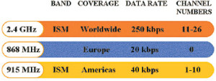](https://www.elprocus.com/wp-content/uploads/2014/05/52.jpg)

Fig 4.14 Physical Layer of ZigBee Protocol

**MAC Layer**: This layer is responsible for reliable transmission of data by accessing different networks with the carrier sense multiple access collision avoidance (CSMA). This also transmits the beacon frames for synchronizing communication.

**Network Layer**: This layer takes care of all network related operations such as network setup, end device connection and disconnection to network, routing, device configurations, etc.

**Application Support Sub-Layer**: This layer enables the services necessary for ZigBee device object and application objects to interface with the network layers for data managing services. This layer is responsible for matching two devices according to their services and needs.

**Application Framework**: It provides two types of data services as key value pair and generic message services. Generic message is a developer defined structure, whereas the key value pair is used for getting attributes within the application objects.

ZDO provides an interface between application objects and APS layer in ZigBee devices. It is responsible for detecting, initiating and binding other devices to the network.

**4.5.3 ZIGBEE OPERATING MODES AND ITS TOPOLOGIES**

[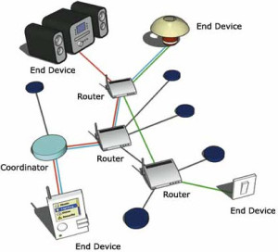](https://www.elprocus.com/wp-content/uploads/2014/05/92.jpg)

Fig 4.15 ZigBee Communication Operation

ZigBee two-way data is transferred in two modes: Non-beacon mode and Beacon mode. In a beacon mode, the coordinators and routers continuously monitor active state of incoming data hence more power is consumed. In this mode, the routers and coordinators do not sleep because at any time any node can wake up and communicate. However, it requires more power supply and its overall power consumption is low because most of the devices are in an inactive state for over long periods in the network.

In a beacon mode, when there is no data communication from end devices, then the routers and coordinators enter into sleep state. Periodically this coordinator wakes up and transmits the beacons to the routers in the network. These beacon networks are work for time slots which means, they operate when the communication needed results in lower duty cycles and longer battery usage. These beacon and non-beacon modes of ZigBee can manage periodic (sensors data), intermittent (Light switches) and repetitive data types.

**4.5.4 ZIGBEE TOPOLOGIES**

[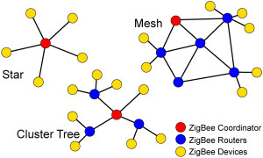](https://www.elprocus.com/wp-content/uploads/2014/05/73.jpg)

Fig 4.16 ZigBee Topologies

ZigBee supports several network topologies; however, the most commonly used configurations are star, mesh and cluster tree topologies. Any topology consists of one or more coordinator. In a star topology, the network consists of one coordinator which is responsible for initiating and managing the devices over the network. All other devices are called end devices that directly communicate with coordinator. This is used in industries where all the end point devices are needed to communicate with the central controller, and this topology is simple and easy to deploy.

In mesh and tree topologies, the ZigBee network is extended with several routers where coordinator is responsible for staring them. These structures allow any device to communicate with any other adjacent node for providing redundancy to the data. If any node fails, the information is routed automatically to other device by these topologies. As the redundancy is the main factor in industries, hence mesh topology is mostly used. In a cluster-tree network, each cluster consists of a coordinator with leaf nodes, and these coordinators are connected to parent coordinator which initiates the entire network.

Due to the advantages of ZigBee technology like low cost and low power operating modes and its topologies, this short-range communication technology is best suited for several applications compared to other proprietary communications, such as Bluetooth, Wi-Fi, etc.

**4.5.5 APPLICATIONS OF ZIGBEE TECHNOLOGY**

**Industrial Automation:** In manufacturing and production industries, a communication link continually monitors various parameters and critical equipment’s. Hence ZigBee considerably reduce this communication cost as well as optimizes the control process for greater reliability.

**Home Automation:** ZigBee is perfectly suited for controlling home appliances remotely as a lighting system control, appliance control, heating and cooling system control, safety equipment operations and control, surveillance, and so on.

**Smart Metering:** ZigBee remote operations in smart metering include energy consumption response, pricing support, security over power theft, etc.

**Smart Grid monitoring:** ZigBee operations in this smart grid involve remote temperature monitoring, fault locating, reactive power management, and so on.

**4.5.6 INTERFACING ZIGBEE WITH 8051**

Fig. 4.17 shows how to interface the ZigBee with microcontroller. The ZigBee modules work at the 2.4 GHz frequency which means smaller board and antenna size. ZigBee modules have the ability to transmit Digital, PWM, Analog or Serial RS232 signals wirelessly. To communicate over UART or USART, we just need three basic signals which are namely, RXD (receive), TXD (transmit), GND (common ground). So to interface UART with 8051, we just need the basic signals.

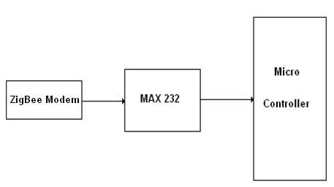

Fig. 4.17 Interfacing ZigBee to Microcontroller

We now want to interface the ZigBee module with 8051 Development board for accessing the mobiles without wires through UART0. The data communication is done in internet by using the ZigBee module through MAX232 into the SBUF register of 8051 microcontroller (refer serial interfacing with 8051). The serial data from the ZigBee receiver is taken by using the Serial Interrupt of the controller. +5V and ground is connected to provide power to the module. While TX and RX pin is connected for communication.

|  |  |  |  |
| --- | --- | --- | --- |
|  | UART DB-9 Connector | 8051  Lines | Serial Port Section |
| UART0(P1)  ISP PGM | TXD-0 | P3.0 | |  | | --- | | serial port section 8051 | |
| RXD-0 | P3.1 |
| UART1  (P2) | TXD-1 | P1.2 |
| RXD-1 | P1.3 |

Table 4.5 Pin Assignment with 8051

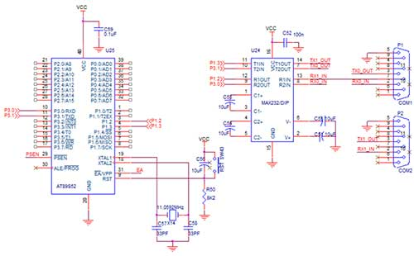

Fig. 4.18 Circuit Diagram to Interface ZigBee with 8051

**4.6 LCD Module**

LCDs can add a lot to any application in terms of providing an useful interface for the user, debugging an application or just giving it a "professional" look. The most common type of LCD controller is the Hitachi 44780 which provides a relatively simple interface between a processor and an LCD. Using this interface is often not attempted by inexperienced designers and programmers because it is difficult to find good documentation on the interface, initializing the interface can be a problem and the displays themselves are expensive.

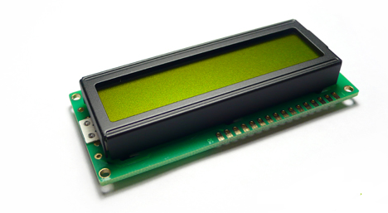

Fig. 4.19 LCD module

The most common connector used for the 44780 based LCDs is 14 pins in a row, with pin center 0.100" apart. The pins are wired as:

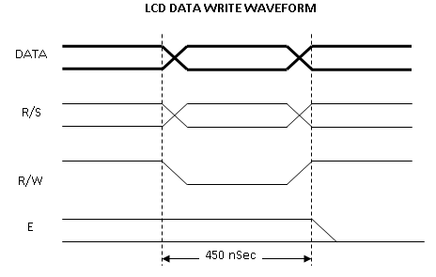

Fig 4.20 LCD data write waveform

|  |  |
| --- | --- |
| **Pins** | **Description** |
| 1 | Ground |
| 2 | Vcc |
| 3 | Contrast Voltage |
| 4 | "R/S" _Instruction/Register Select |
| 5 | "R/W" _Read/Write LCD Registers |
| 6 | "E" Clock |
| 7 to 14 | Data I/O Pins |
| 15 | LED Positive |
| 16 | LED Negative |

Table 4.6 LCD Pin Description

The interface is a parallel bus, allowing simple and fast reading/writing of data to and from the LCD.

The LCD Data Write Waveform will write an ASCII Byte out to the LCD's screen. The ASCII code to be displayed is eight bits long and is sent to the LCD either four or eight bits at a time. If four bit mode is used, two "nibbles" of data (Sent high four bits and then low four bits with an "E" Clock pulse with each nibble) are sent to make up a full eight bit transfer. The "E" Clock is used to initiate the data transfer within the LCD.

Sending parallel data as either four or eight bits are the two primary modes of operation. While there are secondary considerations and modes, deciding how to send the data to the LCD is most critical decision to be made for an LCD interface application.

Most LCD displays have a 44780 and support chip to control the operation of the LCD. The 44780 is responsible for the external interface and provides sufficient control lines for sixteen characters on the LCD. The support chip enhances the I/O of the 44780 to support up to 128 characters on an LCD. From the table above, it should be noted that the first two entries ("8x1", "16x1") only have the 44780 and not the support chip. This is why the ninth character in the 16x1 does not "appear" at address 8 and shows up at the address that is common for a two line LCD.

The Character Set available in the 44780 is basically ASCII. It is "basically" because some characters do not follow the ASCII convention fully (probably the most significant difference is 0x05B or "\" is not available). The ASCII Control Characters (0x008 to 0x01F) do not respond as control characters and may display funny (Japanese) characters.

The last aspect of the LCD to discuss is how to specify a contrast voltage to the Display. Experts typically use a potentiometer wired as a voltage divider. This will provide an easily variable voltage between Ground and Vcc, which will be used to specify the contrast (or "darkness") of the characters on the LCD screen. You may find that different LCDs work differently with lower voltages providing darker characters in some and higher voltages do the same thing in others.

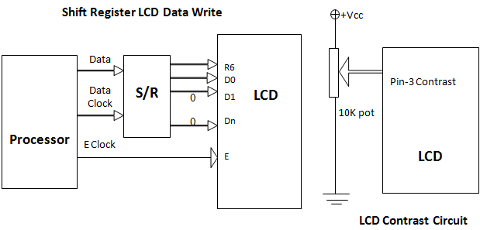

Fig 4.21 Data Shifting and writing on LCD

**4.6.1 FUNCTION DESCRIPTION**

The LCD display Module is built in a LSI controller, the controller has two 8-bit registers, an instruction register (IR) and a data register (DR).

The IR stores instruction codes, such as display clear and cursor shift, and address information for display data RAM (DDRAM) and character generator (CGRAM). The IR can only be written from the MPU. The DR temporarily stores data to be written or read from DDRAM or CGRAM. When address information is written into the IR, then data is stored into the DR from DDRAM or CGRAM.

By the register selector (RS) signal, these two registers can be selected.



Table 4.7 LCD Register select Table

**Busy Flag (BF)**

When the busy flag is 1, the controller LSI is in the internal operation mode, and the next instruction will not be accepted. When RS=0 and R/W=1, the busy flag is output to DB7. The next instruction must be written after ensuring that the busy flag is 0.

**Address Counter (AC)**

The address counter (AC) assigns addresses to both DDRAM and CGRAM

**Display Data RAM (DDRAM)**

This DDRAM is used to store the display data represented in 8-bit character codes. Its extended capacity is 80×8 bits or 80 characters. Below figure are the relationships between DDRAM addresses and positions on the liquid crystal display.





**Character Generator ROM (CGROM)**

The CGROM generate 5×8 dot or 5×10 dot character patterns from 8-bit character codes. See Table 2.

**Character Generator RAM (CGRAM)**

In CGRAM, the user can rewrite character by program. For 5×8 dots, eight character patterns can be written, and for 5×10 dots, four character patterns can be written.

Write into DDRAM the character code at the addresses shown as the left column of table 1. To show the character patterns stored in CGRAM.

**4.6.2 DEFINITION OF PANEL SERVICE LIFE**

1. Contrast becomes 30% of initial value
2. Current consumption becomes three times higher than initial value
3. Remarkable alignment deterioration occurs in LCK cell layer
4. Unusual operation occurs in display functions

**4.6.3 SAFETY**

If the LCD panel breaks, be careful not to get the liquid crystal in your mouth. If the liquid crystal touches your skin or clothes, wash it off immediately using soap and plenty of water.

**Handling**

1. Avoid static electricity as this can damage the CMOS LSI.
2. The LCD panel is plate glass; do not hit or crush it.
3. Do not remove the panel or frame from the module.
4. The polarizing plate of the display is very fragile handle it very carefully
5. Mounting and Design
6. Mount the module by using the specified mounting part and holes.
7. To protect the module from external pressure leave a small gap by placing transparent plates (e.g. acrylic or glass) on the display surface, frame, and polarizing plate
8. Design the system so that no input signal is given unless the power-supply voltage is applied.
9. Keep the module dry. Avoid condensation otherwise the transparent electrodes may break.

**4.7 ESP8266**

The ESP8266 is a low-cost Wi-Fi microchip with full TCP/IP stack and microcontroller capability produced by Shanghai-based Chinese manufacturer, Espressif Systems.

The chip first came to the attention of western makers in August 2014 with the ESP-01 module, made by a third-party manufacturer, Ai-Thinker. This small module allows microcontrollers to connect to a Wi-Fi network and make simple TCP/IP connections using Hayes-style commands. However, at the time there was almost no English-language documentation on the chip and the commands it accepted. The very low price and the fact that there were very few external components on the module which suggested that it could eventually be very inexpensive in volume, attracted many hackers to explore the module, chip, and the software on it, as well as to translate the Chinese documentation. The ESP8285 is an ESP8266 with 1 MB of built-in flash, allowing for single-chip devices capable of connecting to Wi-Fi. The successor to these microcontroller chips is the ESP32.

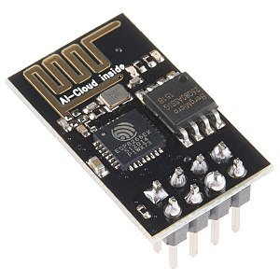

Fig 4.22 ESP-01 Module

**4.7.1 FEATURES**

* Processor: L106 32-bit RISC microprocessor core based on the Tensilica Xtensa Diamond Standard 106Micro running at 80 MHz.
* 32 KB instruction RAM.
* 32 KB instruction cache RAM.
* 80 KB user data RAM.
* 16 KB ETS system data RAM.
* External QSPI flash: up to 16 MB is supported (512 KiB to 4 MB typically included).
* IEEE 802.11 b/g/n Wi-Fi.
* Integrated TR switch, balun, LNA, power amplifier and matching network.
* WEP or WPA/WPA2 authentication, or open networks.
* 16 GPIO pins.
* SPI.
* I²C (software implementation).
* I²S interfaces with DMA (sharing pins with GPIO).
* UART on dedicated pins, plus a transmit-only UART can be enabled on GPIO2.
* 10-bit ADC (successive approximation ADC).

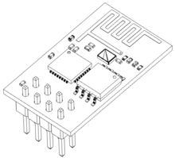

Fig 4.23 ESP Wireframe

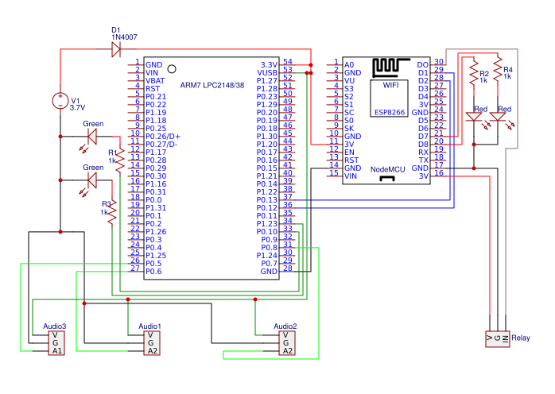

Fig 4.24 Interfacing ARM with ESP8266

**4.8 VIBRATION SENSOR**

This module features an adjustable potentiometer, a vibration sensor, and a LM393 comparator chip to give an adjustable digital output based on the amount of vibration. The potentiometer can be adjusted to both increase and decrease the sensitivity to the desired amount. The module outputs a logic level high (VCC) when it is triggered and a low (GND) when it isn’t. Additionally there is an onboard LED that turns on when the module is triggered.

Vibration sensor is used originally as vibration switch because of its high sensitivity; it is sensitive to environment vibration, and generally used to detect the ambient vibration strength. When module did not reach the threshold in shock or vibration strength, DO port output gets high level and when external vibration strength exceeds the threshold, D0 port output gets low level. Small digital output D0 can be directly connected to the microcontroller, for the microcontroller to detect low level, thereby to detect the ambient vibration. Small digital output DO can directly drive the relay module, which can be composed of a vibration switch.

A piezoelectric sensor is a device that uses the [piezoelectric effect](https://en.wikipedia.org/wiki/Piezoelectric_effect), to measure changes in [pressure](https://en.wikipedia.org/wiki/Pressure), [acceleration](https://en.wikipedia.org/wiki/Acceleration), [temperature](https://en.wikipedia.org/wiki/Temperature), [strain](https://en.wikipedia.org/wiki/Strain_(materials_science)), or [force](https://en.wikipedia.org/wiki/Force) by converting them to an [electrical charge](https://en.wikipedia.org/wiki/Electrical_charge).

**4.8.1 SPECIFICATIONS**

• The default state of the switch is open

• Digital output

• Supply voltage: 3.3V-5V

• On-board LM393 voltage Comparator chip and Vibration sensing probe

• Signal detection sensitivity can be adjusted.

• Dimension: 3cm x 1.5cm

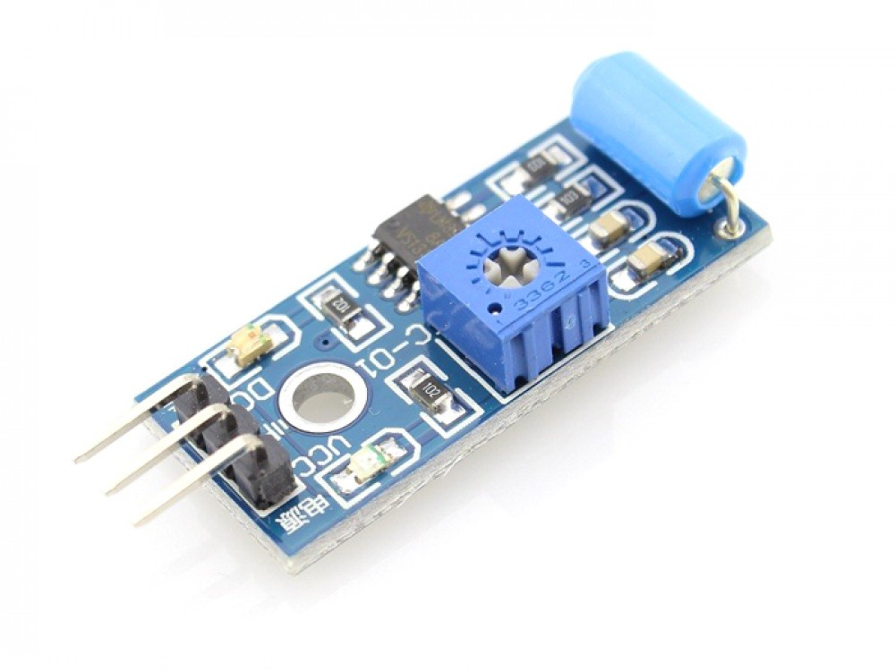

Fig 4.25 Vibration Sensor

**4.8.2 BOARD SCHEMATIC**



Fig 4.26 Board Schematic

**Sensor Details** - SW-420 Single-roller type full induction trigger switch. When no vibration or tilt, the product is ON conduction state, and in the steady state, when a vibration or tilt, the switch will be rendered instantly disconnect the conductive resistance increases, generating a current pulse signal, thereby triggering circuit.

**Principle** - Usually at any angle switch is ON state, by the vibration or movement, the rollers of the conduction current in the switch will produce a movement or vibration, causing the current through the disconnect or the rise of the resistance and trigger circuit. The characteristics of this switch is usually general in the conduction state briefly disconnected resistant to vibration, so it's high sensitivity settings by IC, customers according to their sensitivity requirements for adjustments.

**4.8.3 USE**

• The module does not vibrate, vibrate switch is closed conduction state, the output low, the green indicator light comes ON.

• Vibration state, vibration switch instantly disconnect the output high, the green light is not on.

• The output is directly connected to the microcontroller to detect high and low, thereby detecting the vibration environment, play an alarm role.

**4.8.4 COMPONENTS LIST**

|  |  |  |
| --- | --- | --- |
| **COMPONENTS** | **SPECIFICATION** | **QUANTITY** |
| R1,R3,R4 | 1k Ohm | 3 |
| R2,R5 | 10k Ohm | 2 |
| D1,D2 | LED | 2 |
| U1 | LM393 | 1 |

Table 4.8 Components Lists

**4.9 IR SENSORS**

Infrared technology addresses a wide variety of wireless applications. The main areas are sensing and remote controls. In the electromagnetic spectrum, the infrared portion is divided into three regions: near infrared region, mid infrared region and far infrared region.

The wavelengths of these regions and their applications are shown below.

* Near infrared region — 700 nm to 1400 nm — IR sensors, fiber optic
* Mid infrared region — 1400 nm to 3000 nm — Heat sensing
* Far infrared region — 3000 nm to 1 mm — Thermal imaging

The frequency range of infrared is higher than microwave and lesser than visible light.

For optical sensing and optical communication, photo optics technologies are used in the near infrared region as the light is less complex than RF when implemented as a source of signal. Optical wireless communication is done with IR data transmission for short range applications. An infrared sensor emits and/or detects infrared radiation to sense its surroundings.

The working of any Infrared sensor is governed by three laws: Planck’s Radiation law, Stephen – Boltzmann law and Wien’s Displacement law.

Planck’s law states that “every object emits radiation at a temperature not equal to 00K”. Stephen – Boltzmann law states that “at all wavelengths, the total energy emitted by a black body is proportional to the fourth power of the absolute temperature”. According to Wien’s Displacement law, “the radiation curve of a black body for different temperatures will reach its peak at a wavelength inversely proportional to the temperature”.

The basic concept of an Infrared Sensor which is used as Obstacle detector is to transmit an infrared signal, this infrared signal bounces from the surface of an object and the signal is received at the infrared receiver.

There are five basic elements used in a typical infrared detection system: an infrared source, a transmission medium, optical component, infrared detectors or receivers and signal processing. Infrared lasers and Infrared LED’s of specific wavelength can be used as infrared sources. The three main types of media used for infrared transmission are vacuum, atmosphere and optical fibers. Optical components are used to focus the infrared radiation or to limit the spectral response.

Optical lenses made of Quartz, Germanium and Silicon are used to focus the infrared radiation. Infrared receivers can be photodiodes, phototransistors etc. some important specifications of infrared receivers are photosensitivity, detectivity and noise equivalent power. Signal processing is done by amplifiers as the output of infrared detector is very small.

**4.9.1 TYPES OF IR SENSORS**

Infrared sensors can be passive or active. Passive infrared sensors are basically Infrared detectors. Passive infrared sensors do not use any infrared source and detects energy emitted by obstacles in the field of view. They are of two types: quantum and thermal. Thermal infrared sensors use infrared energy as the source of heat and are independent of wavelength. Thermocouples, pyroelectric detectors and bolometers are the common types of thermal infrared detectors.

Quantum type infrared detectors offer higher detection performance and are faster than thermal type infrared detectors. The photosensitivity of quantum type detectors is wavelength dependent. Quantum type detectors are further classified into two types: intrinsic and extrinsic types. Intrinsic type quantum detectors are photoconductive cells and photovoltaic cells.

Active infrared sensors consist of two elements: infrared source and infrared detector. Infrared sources include an LED or infrared laser diode. Infrared detectors include photodiodes or phototransistors. The energy emitted by the infrared source is reflected by an object and falls on the infrared detector.

[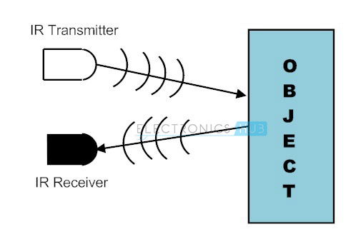](https://www.electronicshub.org/wp-content/uploads/2015/01/1.-IR-Sensors.jpg)

Fig IR sensor working

**4.9.2 IR TRANSMITTER**

Infrared Transmitter is a light emitting diode (LED) which emits infrared radiations. Hence, they are called IR LED’s. Even though an IR LED looks like a normal LED, the radiation emitted by it is invisible to the human eye.

The picture of a typical Infrared LED is shown below.

[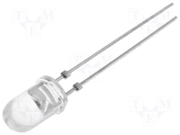](https://www.electronicshub.org/wp-content/uploads/2015/01/IR-LED.png)

Fig 4.27 IR transmitter

There are different types of infrared transmitters depending on their wavelengths, output power and response time.

A simple infrared transmitter can be constructed using an infrared LED, a current limiting resistor and a power supply. The schematic of a typical IR transmitter is shown below.

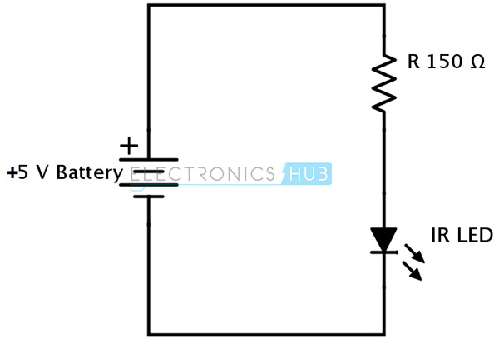

Fig 4.28 IR transmitter circuit

When operated at a supply of 5V, the IR transmitter consumes about 3 to 5 mA of current. Infrared transmitters can be modulated to produce a particular frequency of infrared light. The most commonly used modulation is OOK (ON – OFF – KEYING) modulation.

IR transmitters can be found in several applications. Some applications require infrared heat and the best infrared source is infrared transmitter. When infrared emitters are used with Quartz, solar cells can be made.

**4.9.3 IR RECEIVER**

Infrared receivers are also called as infrared sensors as they detect the radiation from an IR transmitter. IR receivers come in the form of photodiodes and phototransistors. Infrared Photodiodes are different from normal photo diodes as they detect only infrared radiation. The picture of a typical IR receiver or a photodiode is shown below.

[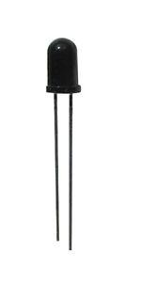](https://www.electronicshub.org/wp-content/uploads/2015/01/IR-Receiver.jpg)

Fig 4.29 IR receiver

Different types of IR receivers exist based on the wavelength, voltage, package, etc. When used in an infrared transmitter – receiver combination, the wavelength of the receiver should match with that of the transmitter.

A typical infrared receiver circuit using a phototransistor is shown below.

[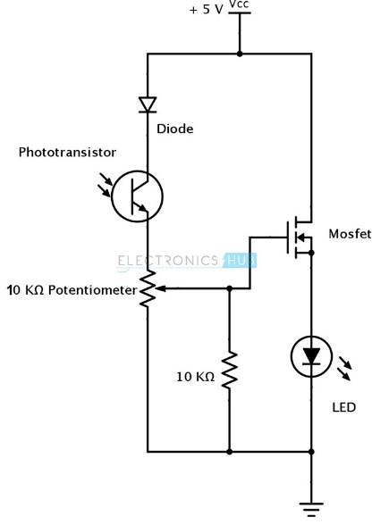](https://www.electronicshub.org/wp-content/uploads/2015/01/3.-Infrared-Receiver.jpg)

Fig 4.30 IR receiver circuit

It consists of an IR phototransistor, a diode, a MOSFET, a potentiometer and an LED. When the phototransistor receives any infrared radiation, current flows through it and MOSFET turns on. This in turn lights up the LED which acts as a load. The potentiometer is used to control the sensitivity of the phototransistor.

**4.9.4 PRINCIPLE OF WORKING**

The principle of an IR sensor working as an Object Detection Sensor can be explained using the following figure. An IR sensor consists of an IR LED and an IR Photodiode; together they are called as Photo – Coupler or Opto – Coupler.

[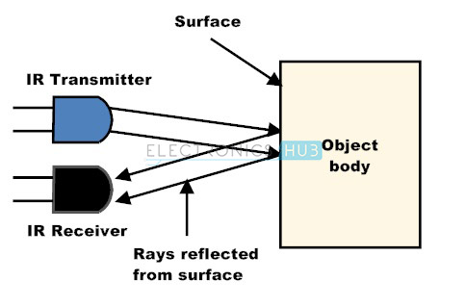](https://www.electronicshub.org/wp-content/uploads/2015/01/4.-Working-principle-of-IR-sensor.jpg)

Fig 4.31 Object Detection Sensor.

When the IR transmitter emits radiation, it reaches the object and some of the radiation reflects back to the IR receiver. Based on the intensity of the reception by the IR receiver, the output of the sensor is defined.

**Obstacle Sensing Circuit or IR Sensor Circuit**

A typical IR sensing circuit is shown below.

[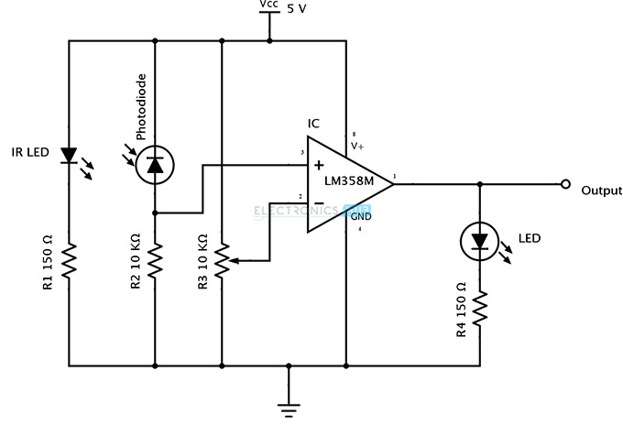](https://www.electronicshub.org/wp-content/uploads/2015/01/5.-IR-Sensor-Circuit.jpg)

Fig 4.32 IR sensing circuit

It consists of an IR LED, a photodiode, a potentiometer, an IC Operational amplifier and an LED.

IR LED emits infrared light. The Photodiode detects the infrared light. An IC Op – Amp is used as a voltage comparator. The potentiometer is used to calibrate the output of the sensor according to the requirement.

When the light emitted by the IR LED is incident on the photodiode after hitting an object, the resistance of the photodiode falls down from a huge value. One of the input of the op – amp is at threshold value set by the potentiometer. The other input to the op-amp is from the photodiode’s series resistor. In the IC, both the threshold voltage and the voltage across the series resistor are compared. If the voltage across the resistor series to photodiode is greater than that of the threshold voltage, the output of the IC Op – Amp is high. As the output of the IC is connected to an LED, it lightens up. The threshold voltage can be adjusted by adjusting the potentiometer depending on the environmental conditions.

The positioning of the IR LED and the IR Receiver is an important factor. When the IR LED is held directly in front of the IR receiver, this setup is called Direct Incidence. In this case, almost the entire radiation from the IR LED will fall on the IR receiver. Hence there is a line of sight communication between the infrared transmitter and the receiver. If an object falls in this line, it obstructs the radiation from reaching the receiver either by reflecting the radiation or absorbing the radiation.